Django Admin Page

**Summary**: in this tutorial, you’ll learn how to create a superuser and use it to sign in to the Django admin page.

# Introduction to the Django admin page

When you create a new project using the startproject command, Django automatically generates the admin page for managing models including creating, reading, updating, and deleting which is often known as CRUD.

To access the admin page, you navigate to the URL <http://127.0.0.1/admin/> . It’ll open the login page:

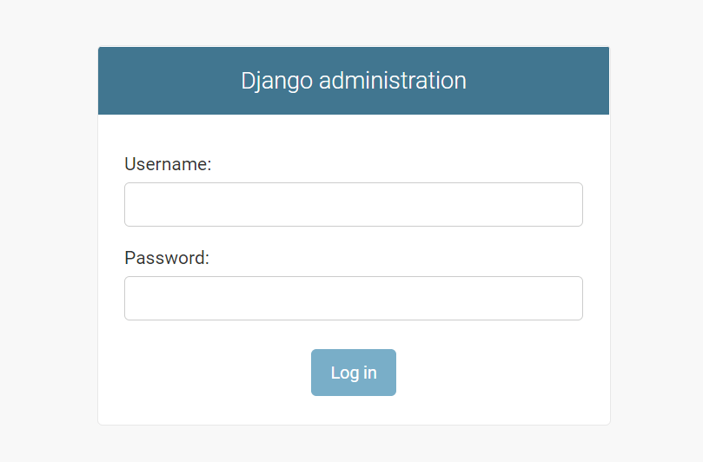

Note that Django specifies the admin/ in the urls.py of the project:

from django.contrib import admin

from django.urls import path, include

urlpatterns = [

path('admin/', admin.site.urls), path('',include('blog.urls'))

]

The Django admin requires an account to log in. Therefore, you need to create a user using a Django command.

## Creating a superuser account

To create a superuser account, you use the createsuperuser command this:

python manage.py createsuperuser

It’ll prompt for a username, email address, and password:

Username: john

Email address: [john@pythontutorial.net](mailto:john@pythontutorial.net) Password:

Password (again):

Superuser created successfully.

Run the Django development server:

python manage.py runserver

And login using the created user, you’ll see the default admin page that manages users & groups:

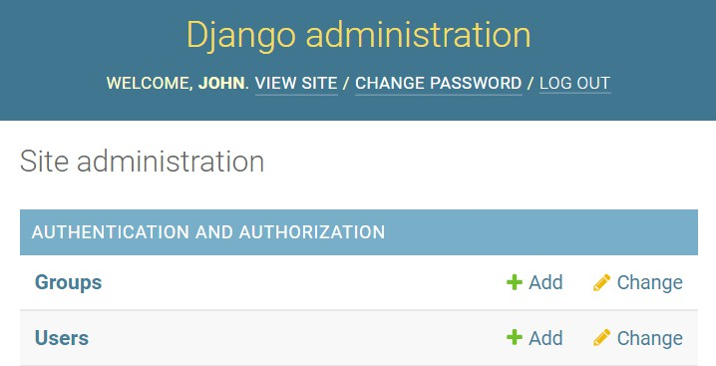

To show the Post model on the admin page, you need to register it in the admin.py of the

blog application:

from django.contrib import admin

from .models import Post

admin.site.register(Post)

In this code:

 First, import the Post from the models.py file.

 Second, register it using the admin.site.register(Post) .

Once you register the model, you’ll see that it appears on the admin site:

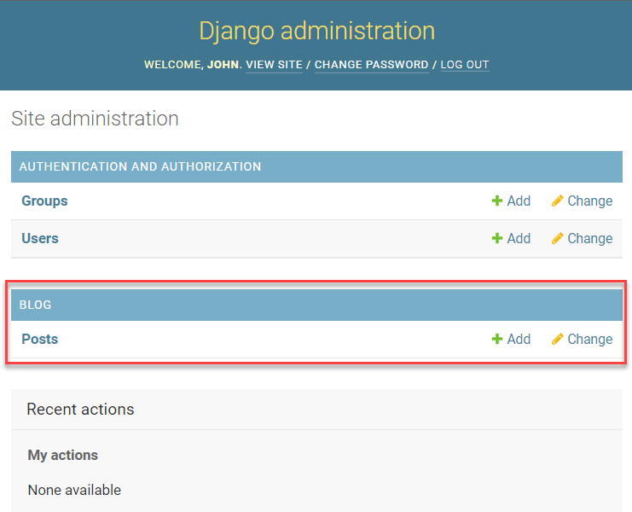

From here, you can manage the posts including creating, updating, deleting, and viewing the posts. For example, you can create a post by clicking the Add button:

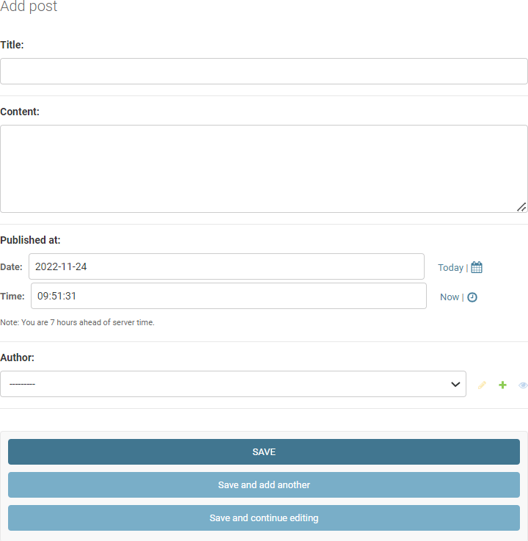

Let’s create three posts:

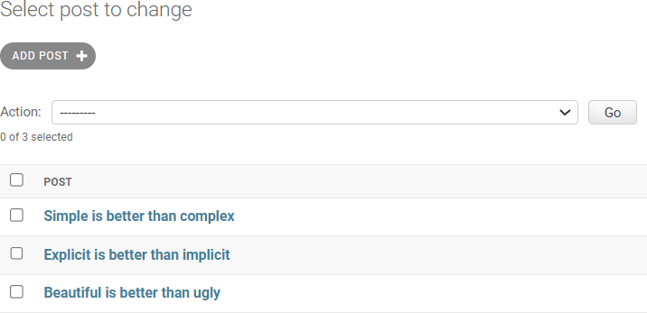

## Display data from the database

To display the posts from the database, you need to change the home() function in the

views.py of the blog application:

from django.shortcuts import render

from .models import Post

def home(request):

posts = Post.objects.all() context = {'posts': posts}

return render(request, 'blog/home.html', context)

def about(request):

return render(request, 'blog/about.html')

How it works.

First, import the Post model from the models.py module:

from .models import Post

Next, get all posts from the database using the Post model:

posts = Post.objects.all()

The all() method returns a QuerySet that contains all Post objects from the database. Note that you’ll learn more about how to interact with the database in the Django ORM section.

Then, create a context dictionary with the key as 'posts' and the value as the posts

QuerySet:

context = {'posts': posts }

After that, pass the context to the render() function:

return render(request,'blog/home.html', context)

Finally, show the posts in the home.html template:



{% extends 'base.html' %}

{% block content %}

<h1>My Posts</h1>

{% for post in posts %}

<h2>{{ post.title }}</h2>

<small>Published on {{ post.published_at | date:"M d, Y" }} by {{ pos

<p>{{ post.content }}</p>

{% endfor %}

{% endblock content %}

If you open the URL <http://127.0.0.1/> , you’ll see three posts from the database:

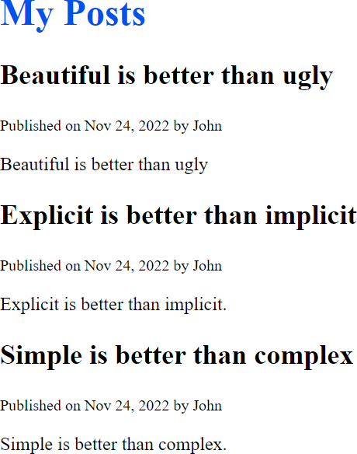

# Summary

 Django comes with a default admin panel that allows you to manage users, groups, and models.

 Use the createsuperuser to create a superuser for logging in to the Django admin site.  Use the admin.site.register method to register a model to the admin panel.

Use the all() method of the Model.objects to get all models as a QuerySet from the database.